LAB 2

HRITIK AJAY BANSAL

CSE A, 15

180905105

Practice Questions 1:

import numpy as np

import pandas as pd

s=pd.Series([3,9,-2,10,5])

sm=s.sum()

print('sum= ',sm)

print('\n')

mn=s.min()

print('min= ',mn)

mx=s.max()

print('\n')

print('max= ',mx)

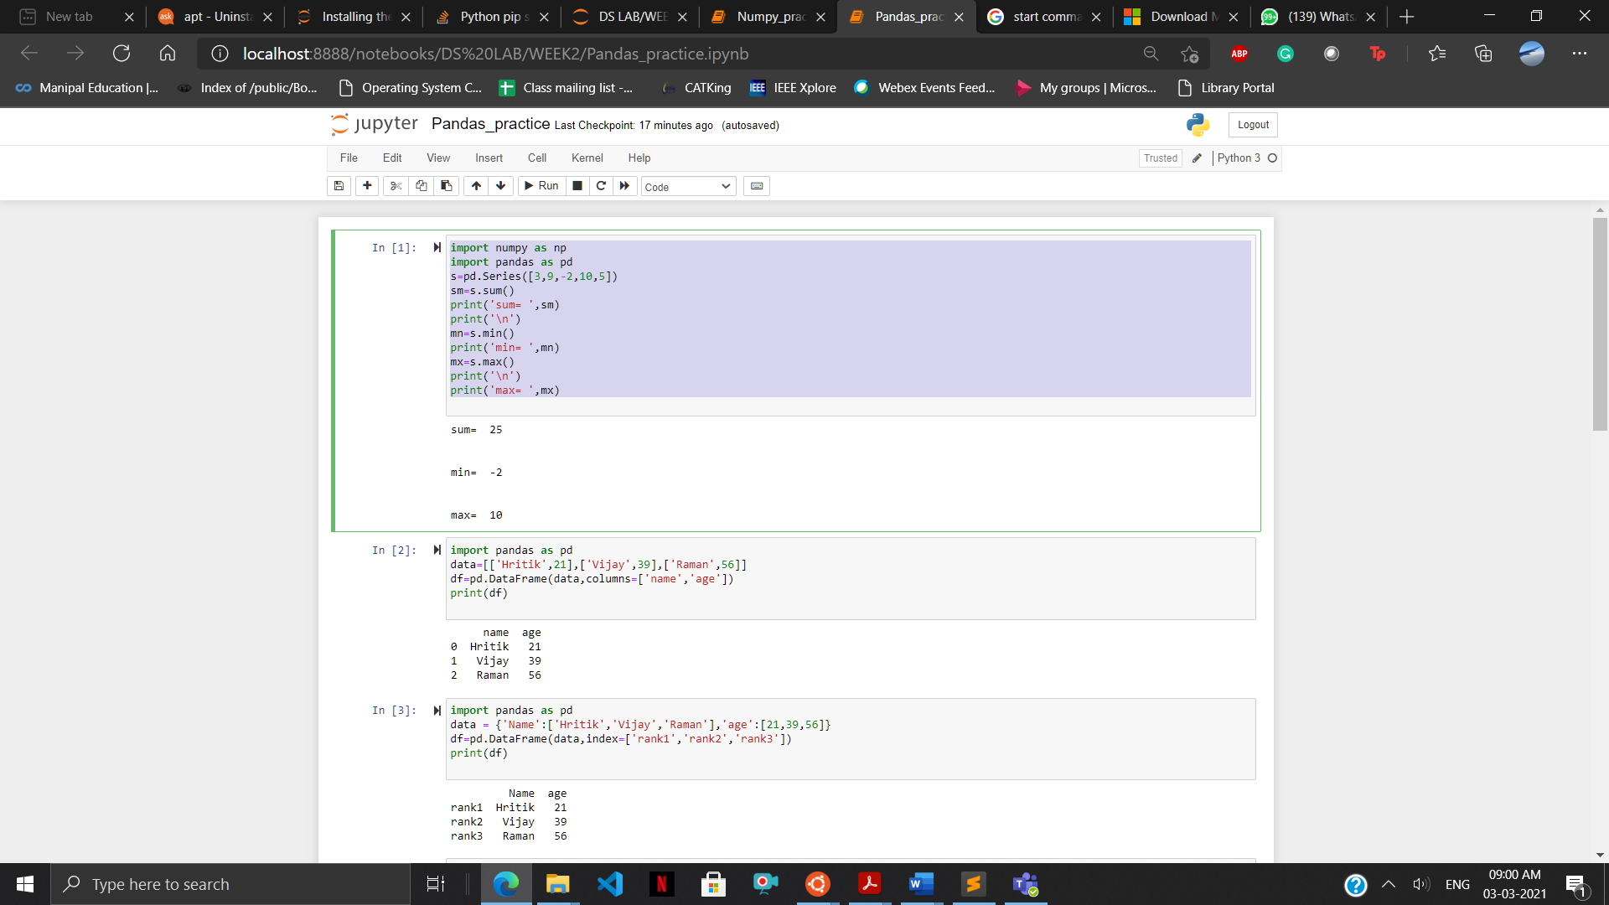

2) import pandas as pd

data=[['Hritik',21],['Vijay',39],['Raman',56]]

df=pd.DataFrame(data,columns=['name','age'])

print(df)

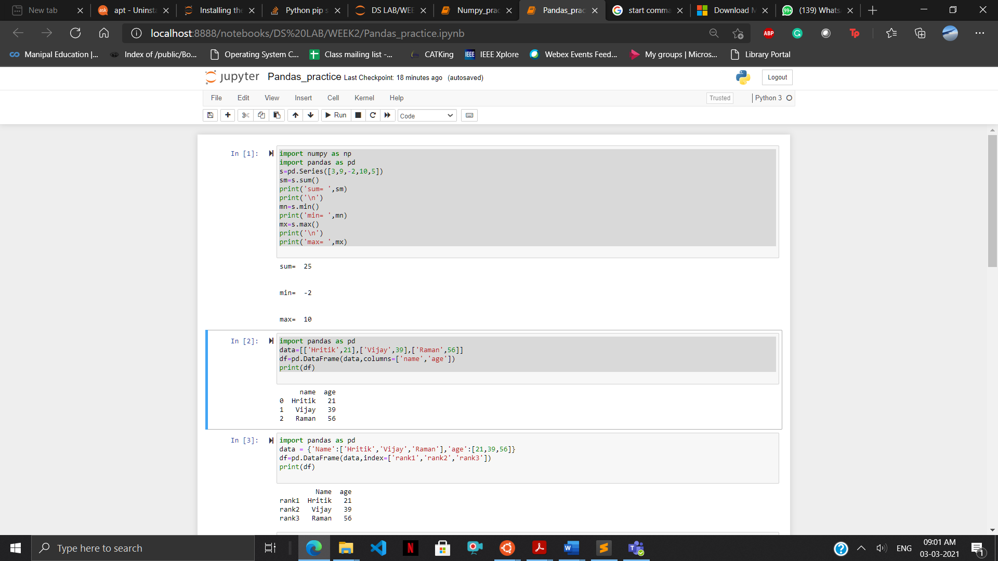

3) import pandas as pd

data = {'Name':['Hritik','Vijay','Raman'],'age':[21,39,56]}

df=pd.DataFrame(data,index=['rank1','rank2','rank3'])

print(df)

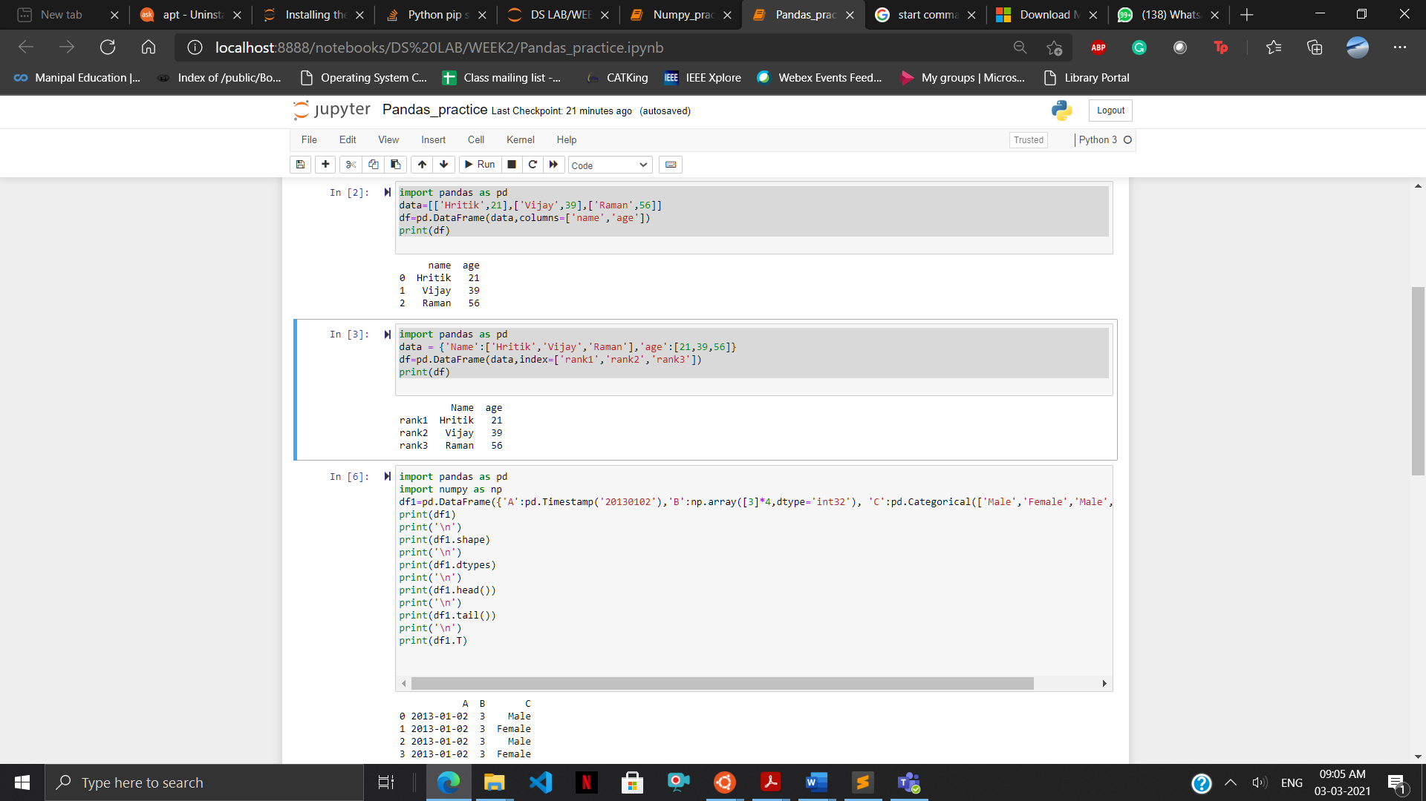

4) import pandas as pd

import numpy as np

df1=pd.DataFrame({'A':pd.Timestamp('20130102'),'B':np.array([3]*4,dtype='int32'), 'C':pd.Categorical(['Male','Female','Male','Female'])})

print(df1)

print('\n')

print(df1.shape)

print('\n')

print(df1.dtypes)

print('\n')

print(df1.head())

print('\n')

print(df1.tail())

print('\n')

print(df1.T)

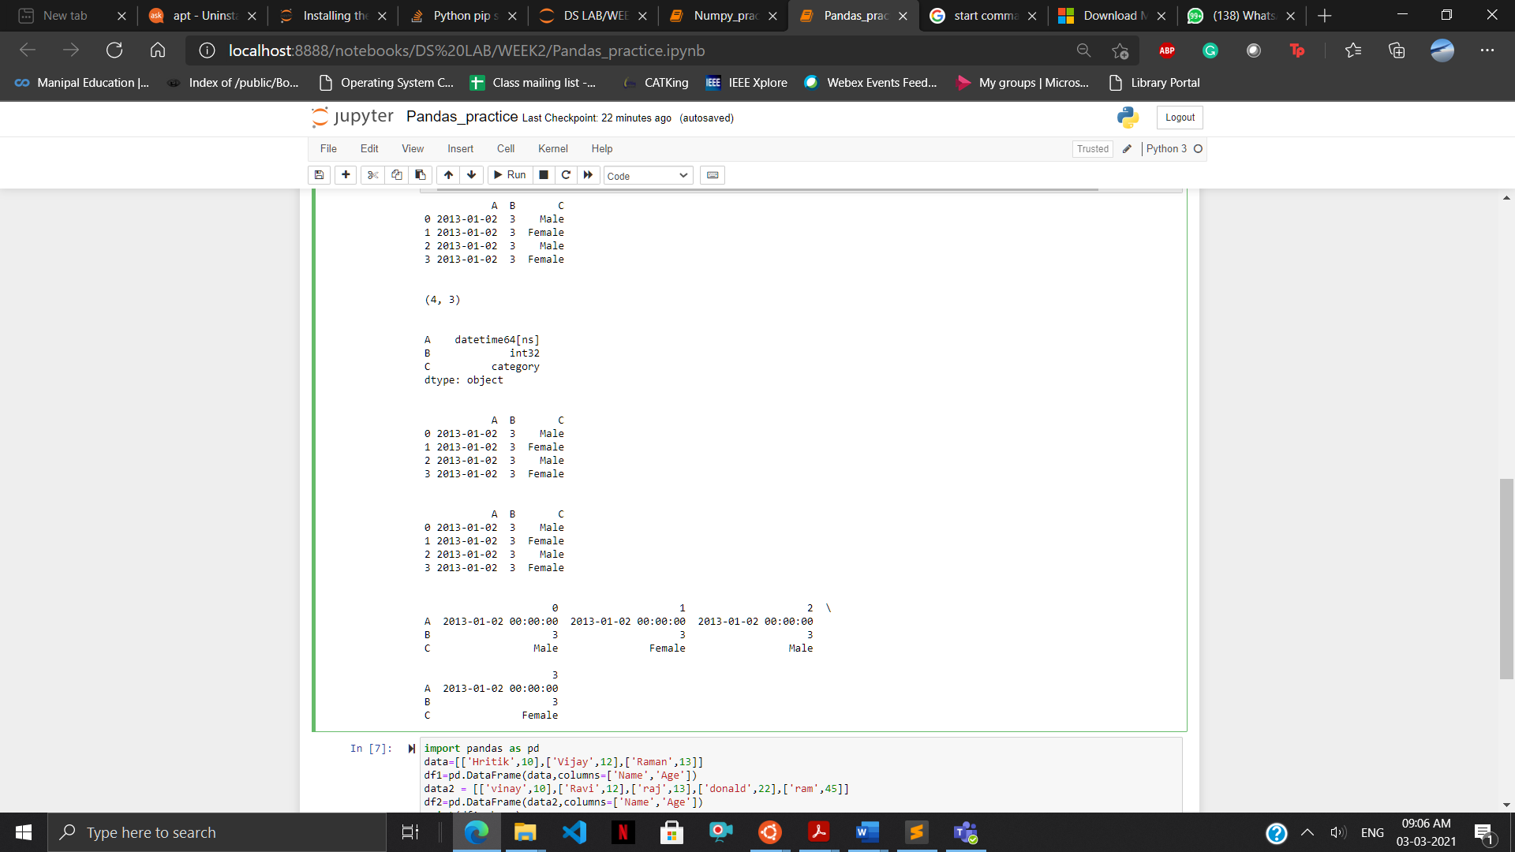

5) import pandas as pd

import numpy as np

data = {'Name':['Hritik','Vijay','Raman'],'age':[21,39,56]}

df=pd.DataFrame(data,index=['rank1','rank2','rank3'])

#print(df)

df1=pd.DataFrame({'A':pd.Timestamp('20130102'),'B':np.array([3]*4,dtype='int32'), 'C':pd.Categorical(['Male','Female','Male','Female'])})

print(df1)

print('\n')

print(df1.head())

print('\n')

print(df1.tail())

print('\n')

print(df1.index)

print('\n')

print(df1.columns)

print('\n')

print(df1.T)

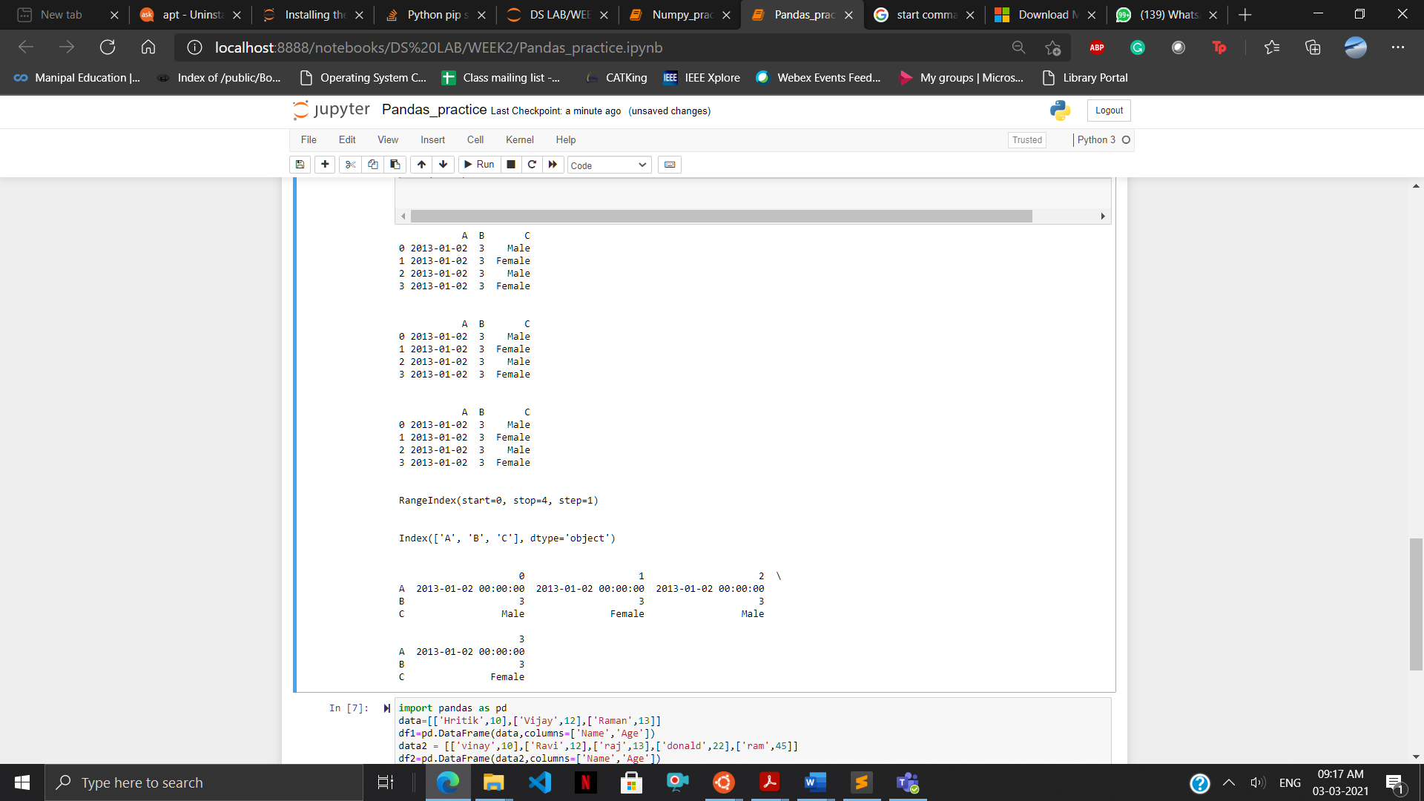

6) Boolean indexing:

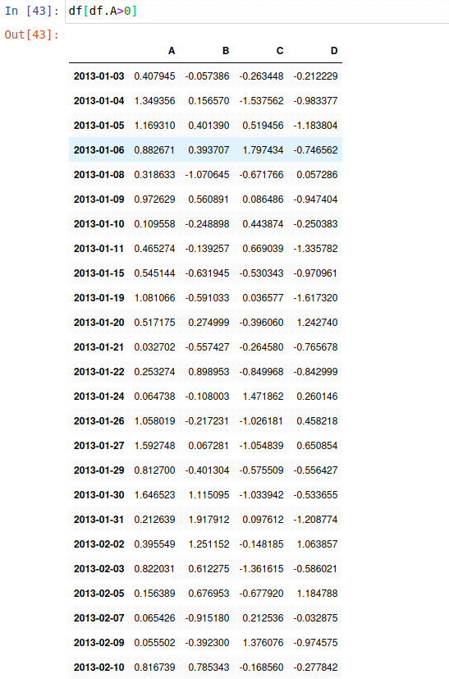

list=['Male']

for i in range(99):

if(i%2==1):

list.append('female')

else:

list.append('male')

df['F']=list

Output:

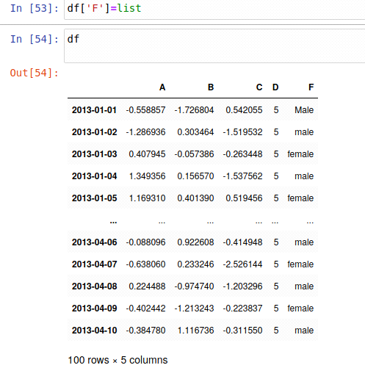

Setting by assigning with a numpy array:

df.loc[:,’D’]=np.array([5]*len(df))

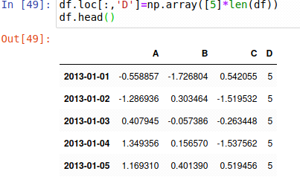

Deleting a row or column:

df.drop (‘A’, axis =1, inplace=True)

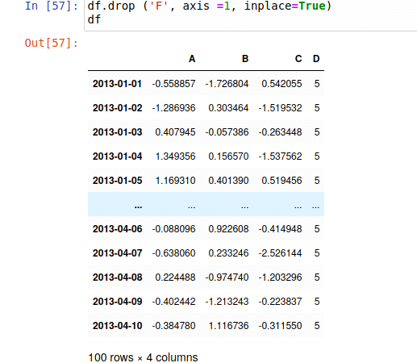

7) import pandas as pd

data=[['Hritik',10],['Vijay',12],['Raman',13]]

df1=pd.DataFrame(data,columns=['Name','Age'])

data2 = [['vinay',10],['Ravi',12],['raj',13],['donald',22],['ram',45]]

df2=pd.DataFrame(data2,columns=['Name','Age'])

print(df1.shape)

print(df2.shape)

Df_new= pd.concat ((df1, df2), axis=1)

print(Df_new.shape)

Df_new2=pd.concat((df1,df2),axis=0)

print(Df_new2.shape)

print(df1.sort_values(by='Age'))

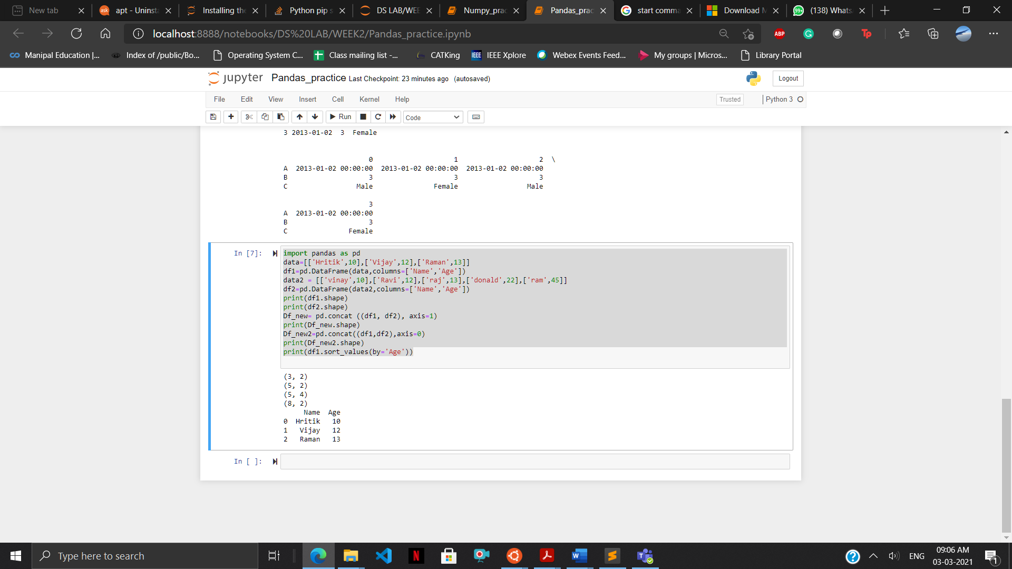

Practice Questions 2:

1) #numpy practice

import pandas as pd

import numpy as np

import matplotlib.pyplot as plt

#Reading a CSV file

df=pd.read_csv('prima_indians_diabetes.csv',header=None)

print(df.head())

print('\n')

print(df.tail())

df.columns=['preg','glu','bp','sft','ins','bmi','dpf','age','class']

plt.scatter(df['bmi'],df['glu'])

plt.xlabel('bmi')

plt.ylabel('Glucose')

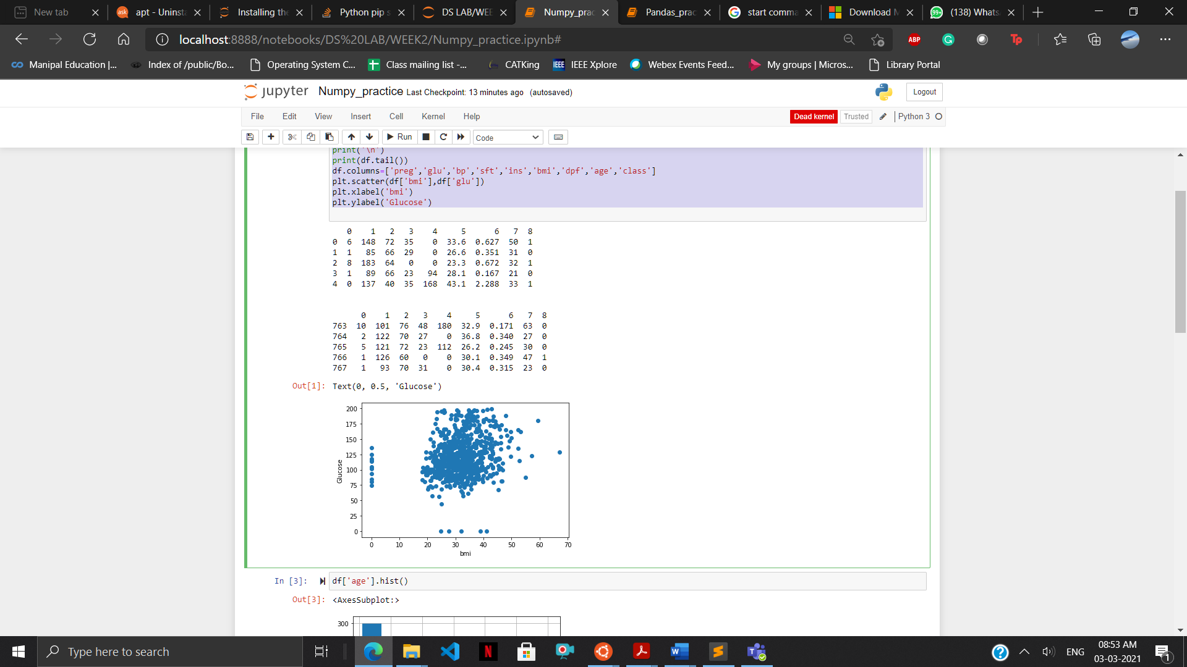

2) df['age'].hist()

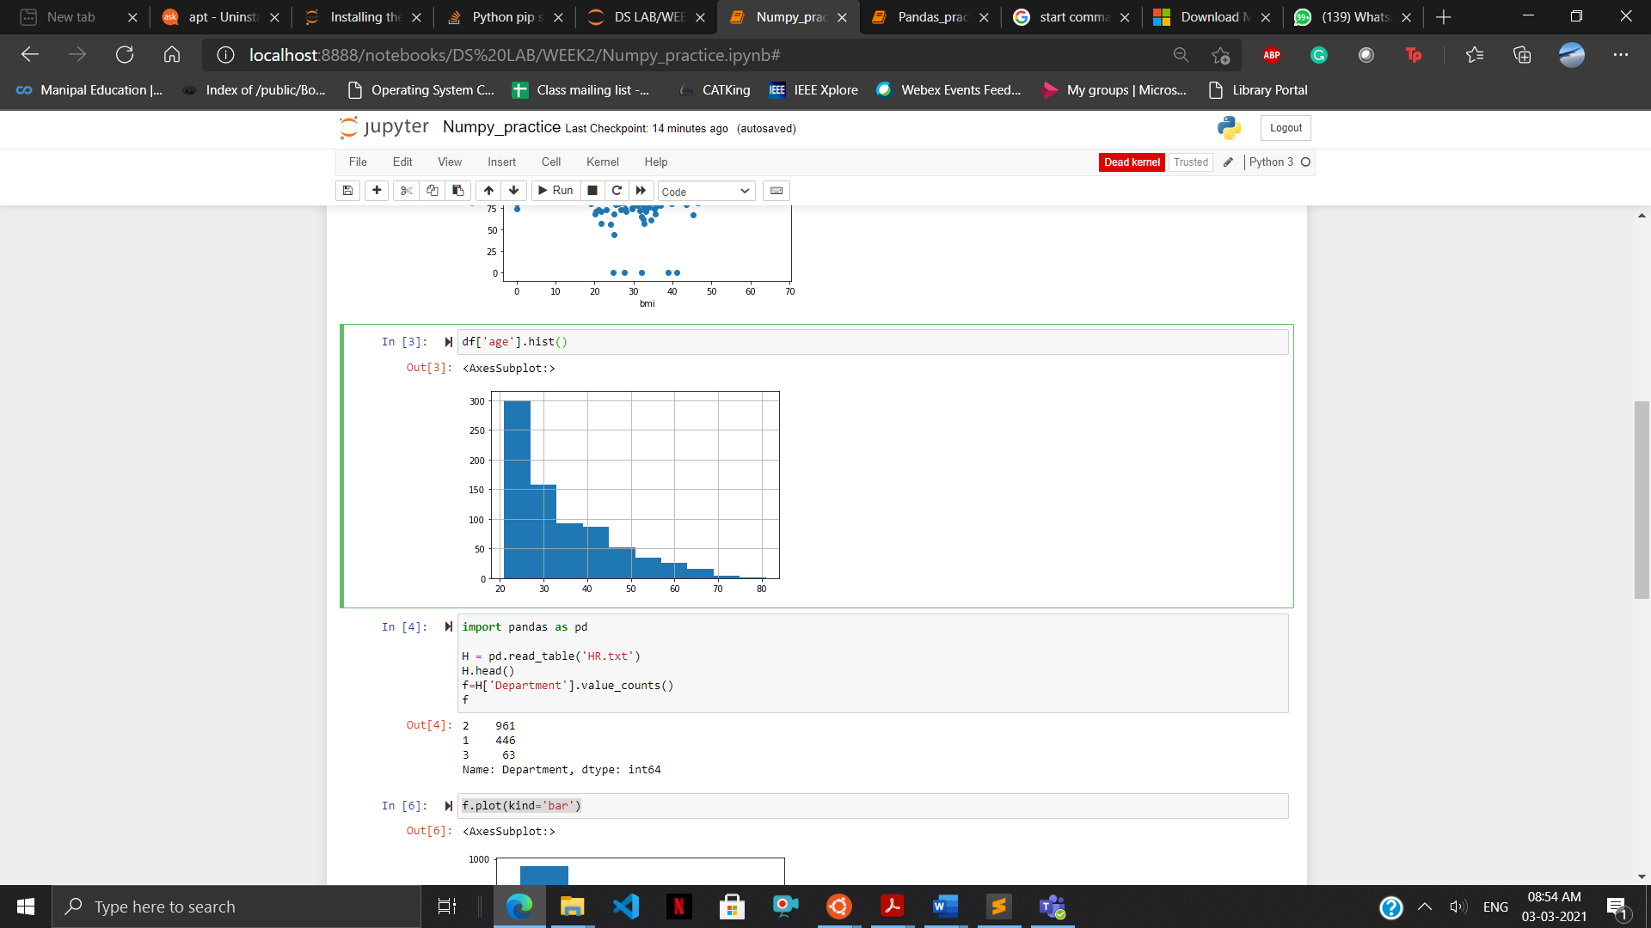

3) import pandas as pd

import numpy as np

import xlrd

import matplotlib.pyplot as plt

df=pd.read_excel('\\wsl$\Ubuntu-18.04\home\hritik\LabsSem6\DS LAB\WEEK2\German Credit.xlsx')

plt.scatter(df['Creditability'],df['CreditAmount'])

plt.xlabel('Creditability')

plt.ylabel('CreditAmount')

plt.show()

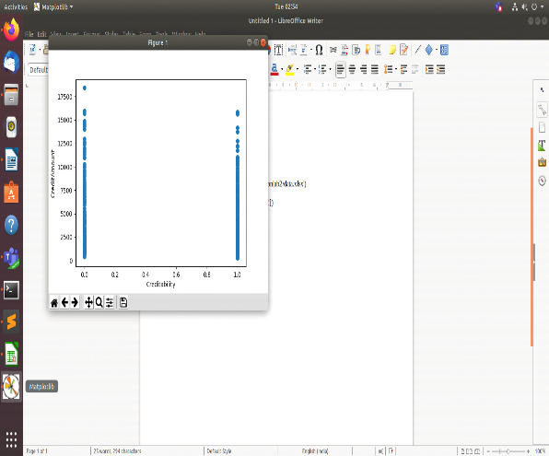

4)import pandas as pd

H = pd.read_table('HR.txt')

H.head()

f=H['Department'].value_counts()

f

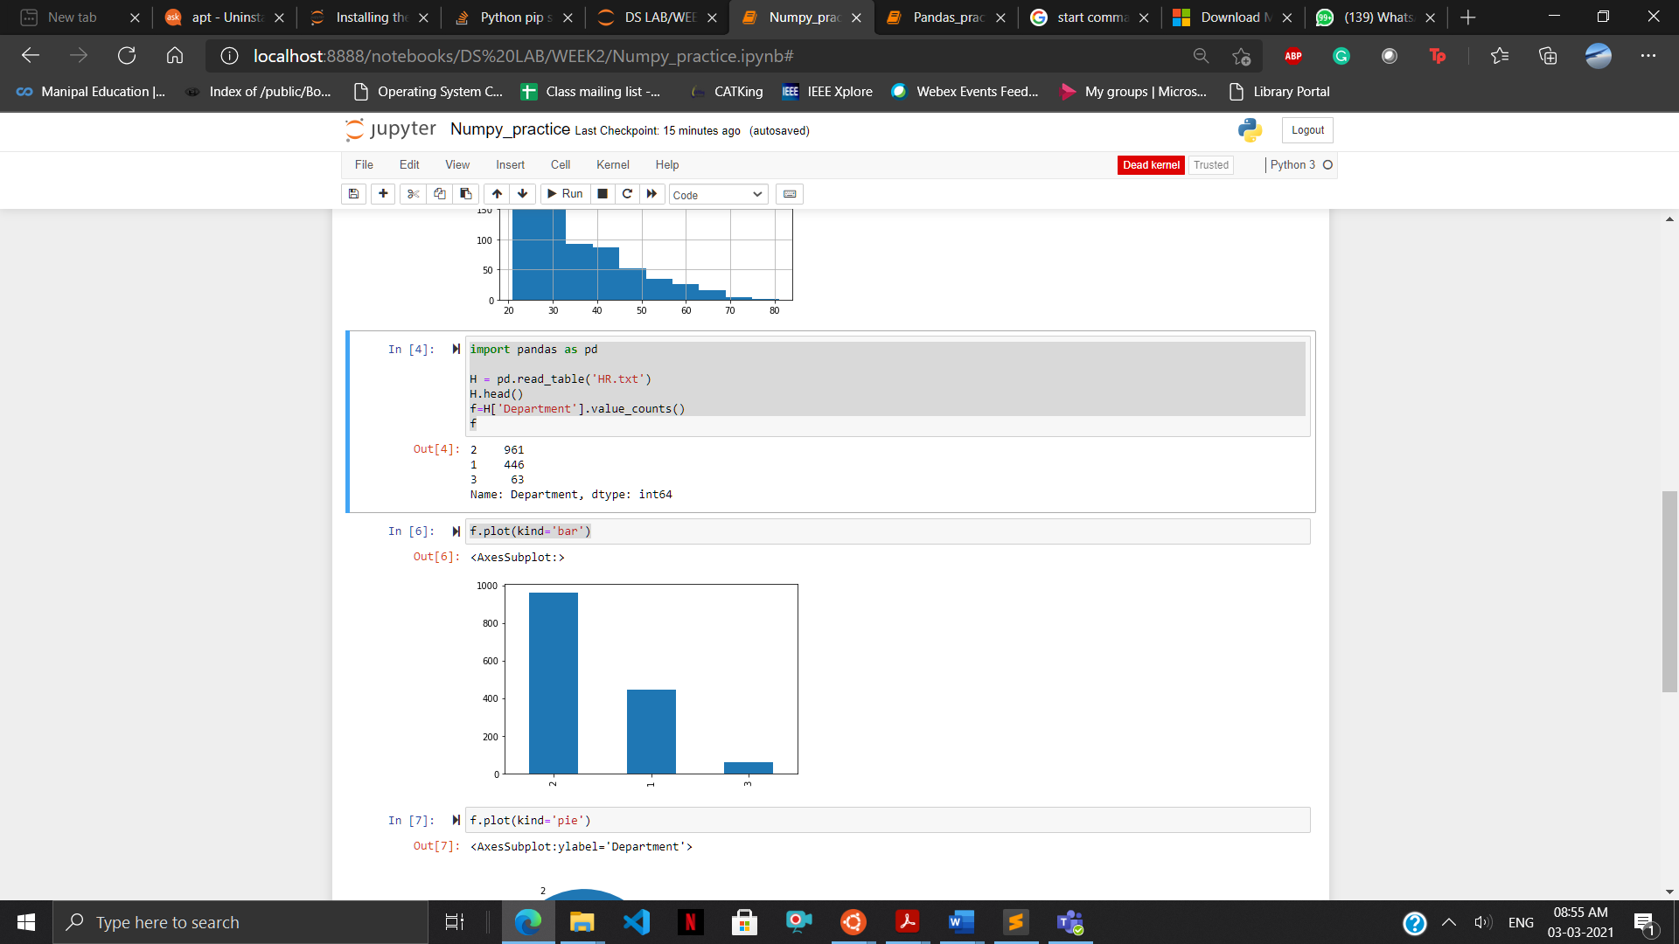

5) f.plot(kind='bar')

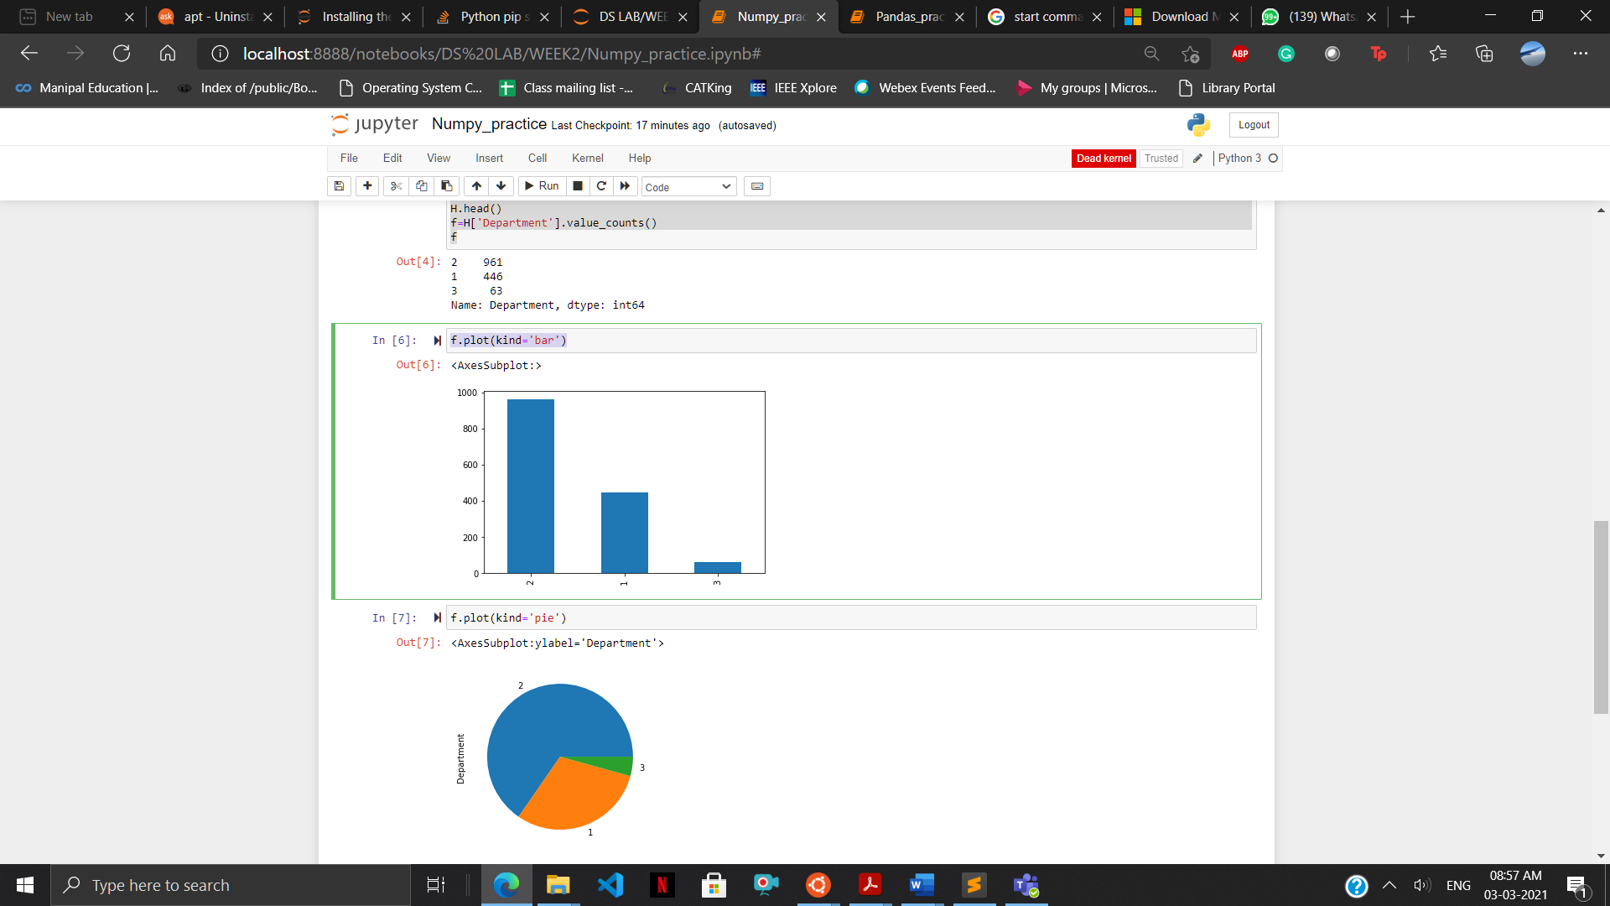

6) f.plot(kind='pie')

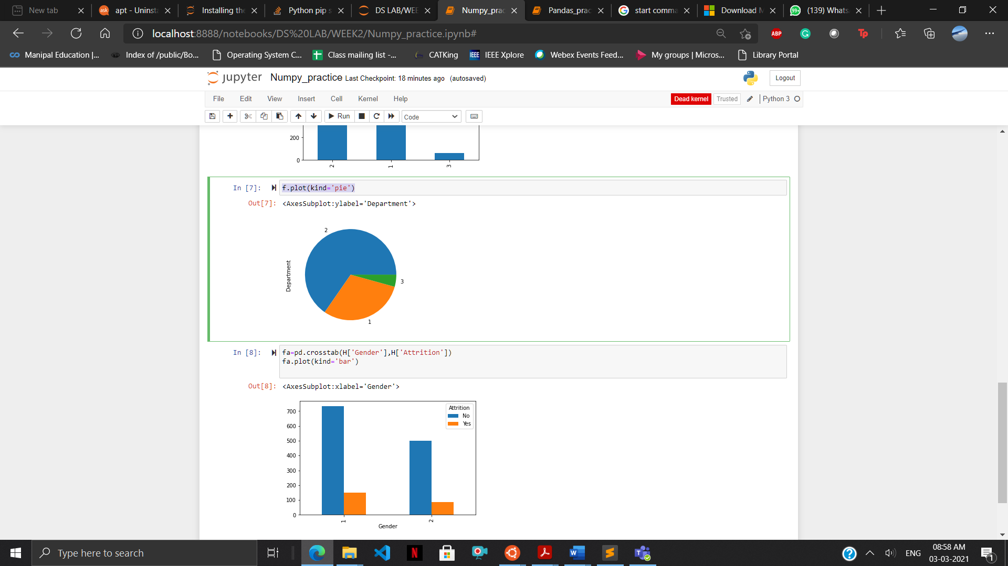

7) fa=pd.crosstab(H['Gender'],H['Attrition'])

fa.plot(kind='bar')

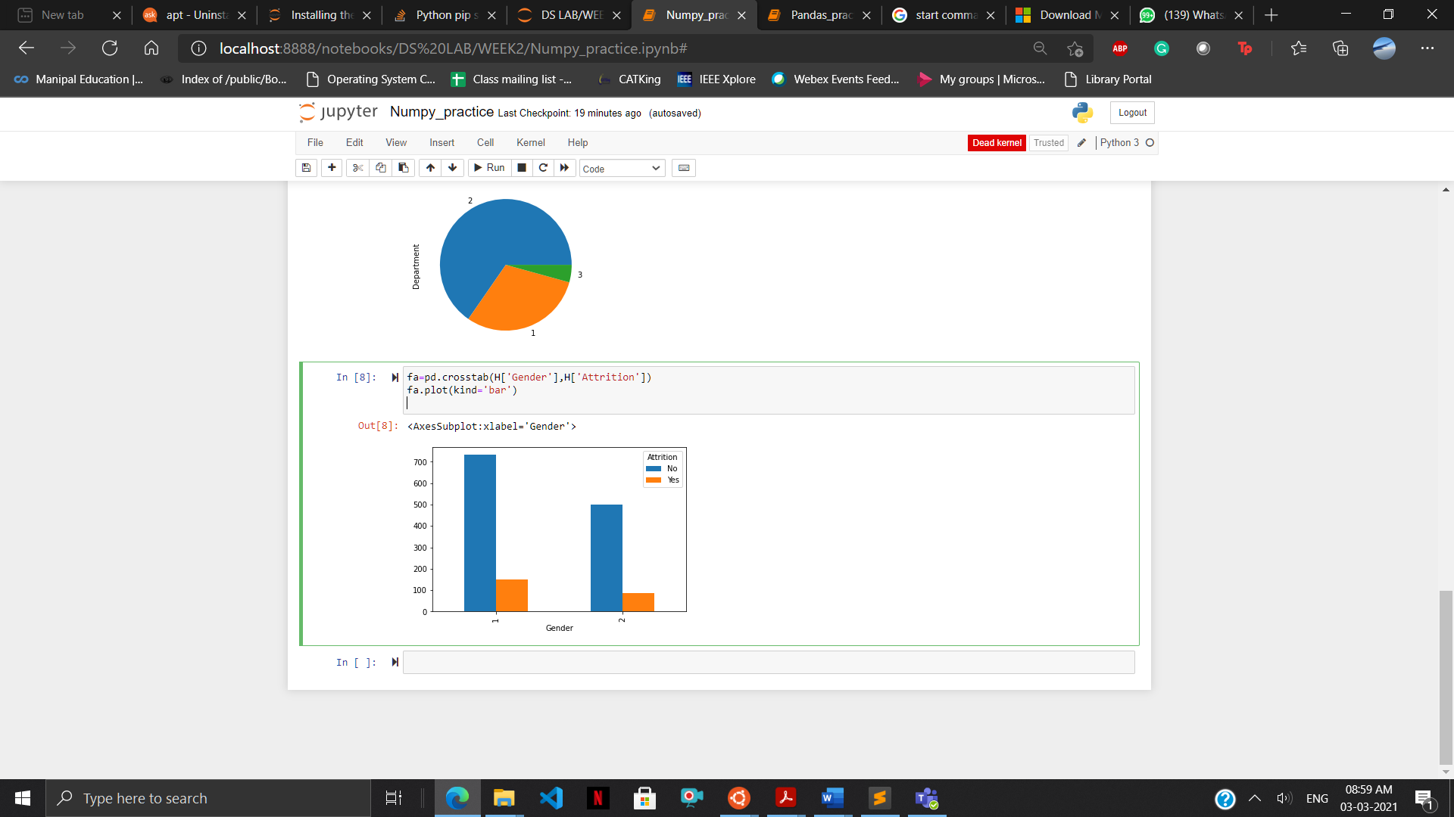

LAB EXERCISES:

Q1-12)

print("\nQuestion 1")

x=int(input("enter height "))

y=int(input("enter height "))

print("the area is ",x*y)

print("\nQuestion 2")

x=int(input("enter no1 "))

y=int(input("enter no2 "))

x=x+y

y=x-y

x=x-y

print("x is ",x,"and","y is ",y)

print("\nQuestion 3")

print("no is ",x)

if x%2==0:

print(x,"is even")

else:

print(x," is odd")

print("\nQuestion 4")

a=int(input("enter no1 "))

b=int(input("enter no2 "))

c=int(input("enter no3 "))

a=a if a>b and a>c else b if b>a and b>c else c

print(a," is the largest of the 3")

print("\nQuestion 5")

print("while loop with else")

a=[1,2,3,4]

i=0

while(i<len(a)) :

print(a[i],end=" ")

i=i+1

else:

print("index out of bounds")

print("\nQuestion 6")

x=int(input("enter the range no"))

j=2

while (j<x):

z=2

count=0

while(z<j):

if j%z==0:

count=1

z=z+1

j=j+1

if count==0:

print(z,end=" ")

print()

print("\nQuestion 7")

a=[1,2,3,4,5,6]

print("length of array is ",len(a))

print("elements of array are ")

print(a)

a.reverse()

print(" REVERSED ARRAY IS ")

print(a)

print("\nQuestion 8")

a= tuple((1,3,5,7,9,2,4,6,8,10))

for i in a[0:int(len(a)/2)]:

print(i,end=" ")

print()

for i in a[int(len(a)/2):len(a)]:

print(i,end=" ")

print()

print("\nQuestion 9")

a=[]

b=tuple((12,7,38,56,78))

for i in b:

if i%2==0:

a.append(i)

a=tuple(a)

print("new tupele ", a)

print("\nQuestion 10")

a=[11,-21,0,45,66,-93]

print("the list is ",a)

print("negative elements are: ")

for i in a:

if i<0:

print(i,end=" ")

print()

print("\nQuestion 11")

a=[11,-21,0,45,66,-93]

print("print neg using while")

i=0

while(i<len(a)):

if a[i]<0:

print(i,end=" ")

i=i+1

print()

print("\nQuestion 12")

a=[11,-21,0,45,66,-93]

print("the list is ",a)

print("negative elements are: ")

for i in a:

if i<0:

print(i,end=" ")

print()

print("positive elements are: ")

for i in a:

if i>0:

print(i,end=" ")

print()

print("\nQuestion 13")

a=[11,-21,0,45,66,-93]

print("the list is ",a)

print("after removing all even elements")

b=a

for i in b:

if i%2==0:

a.remove(i)

print(a)

print()

Output:

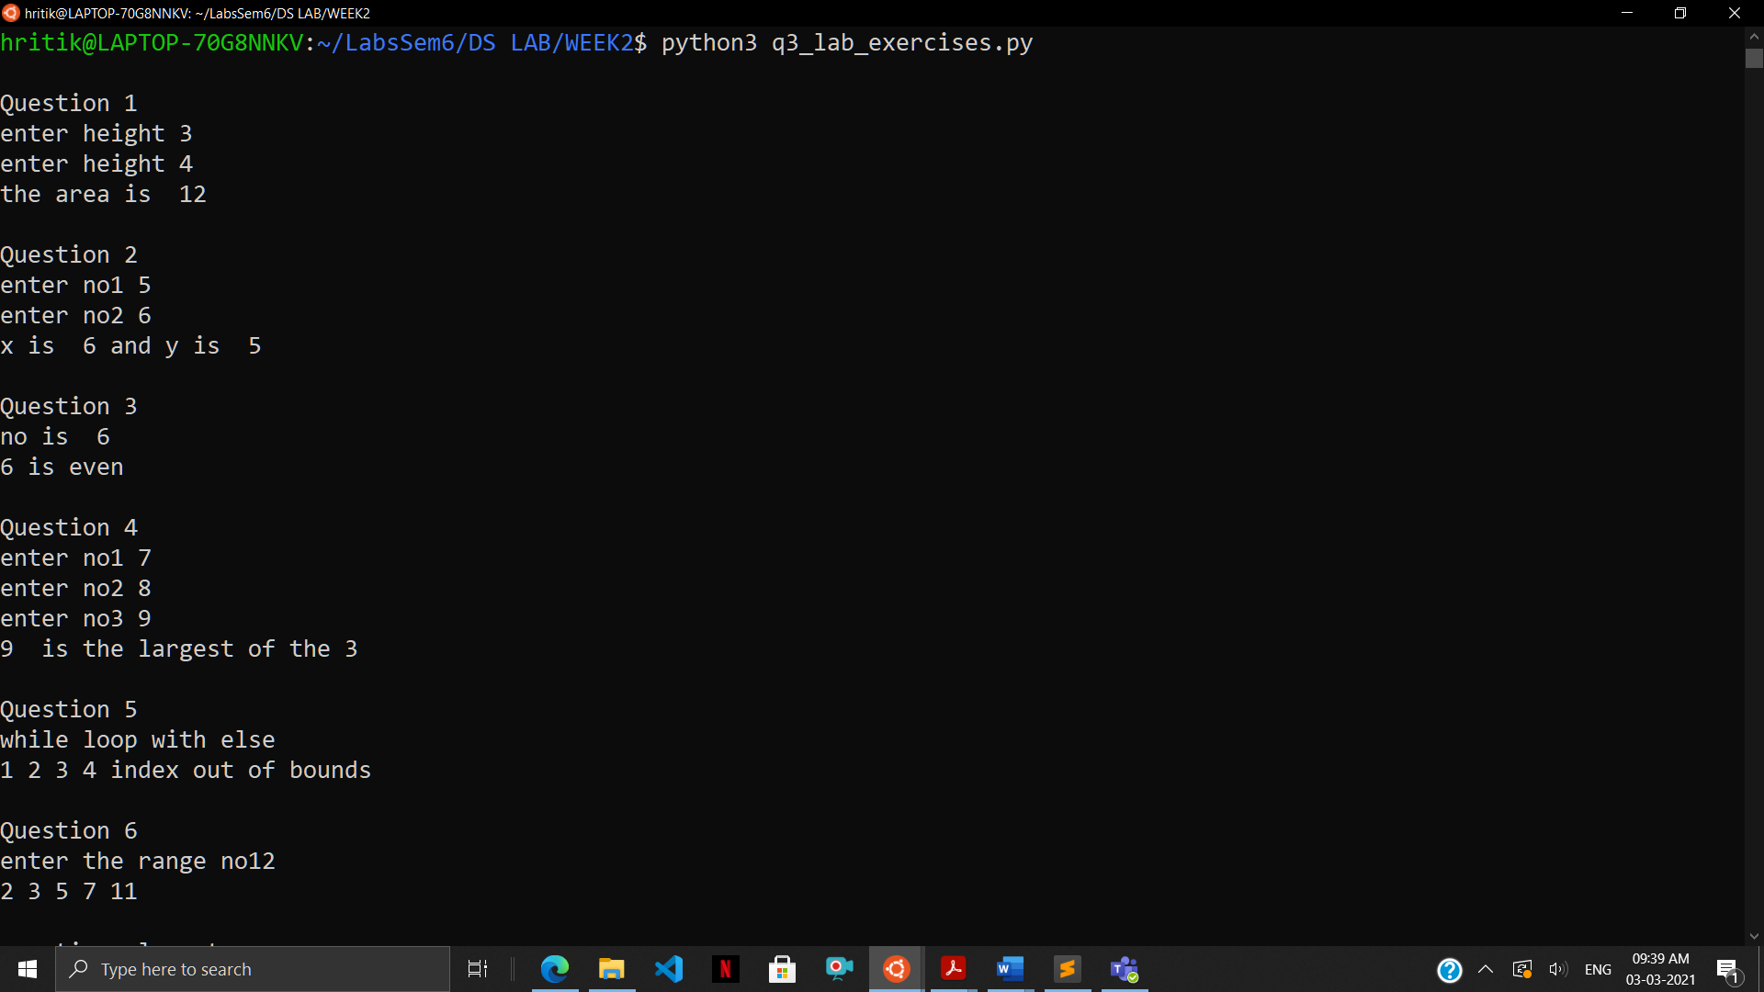

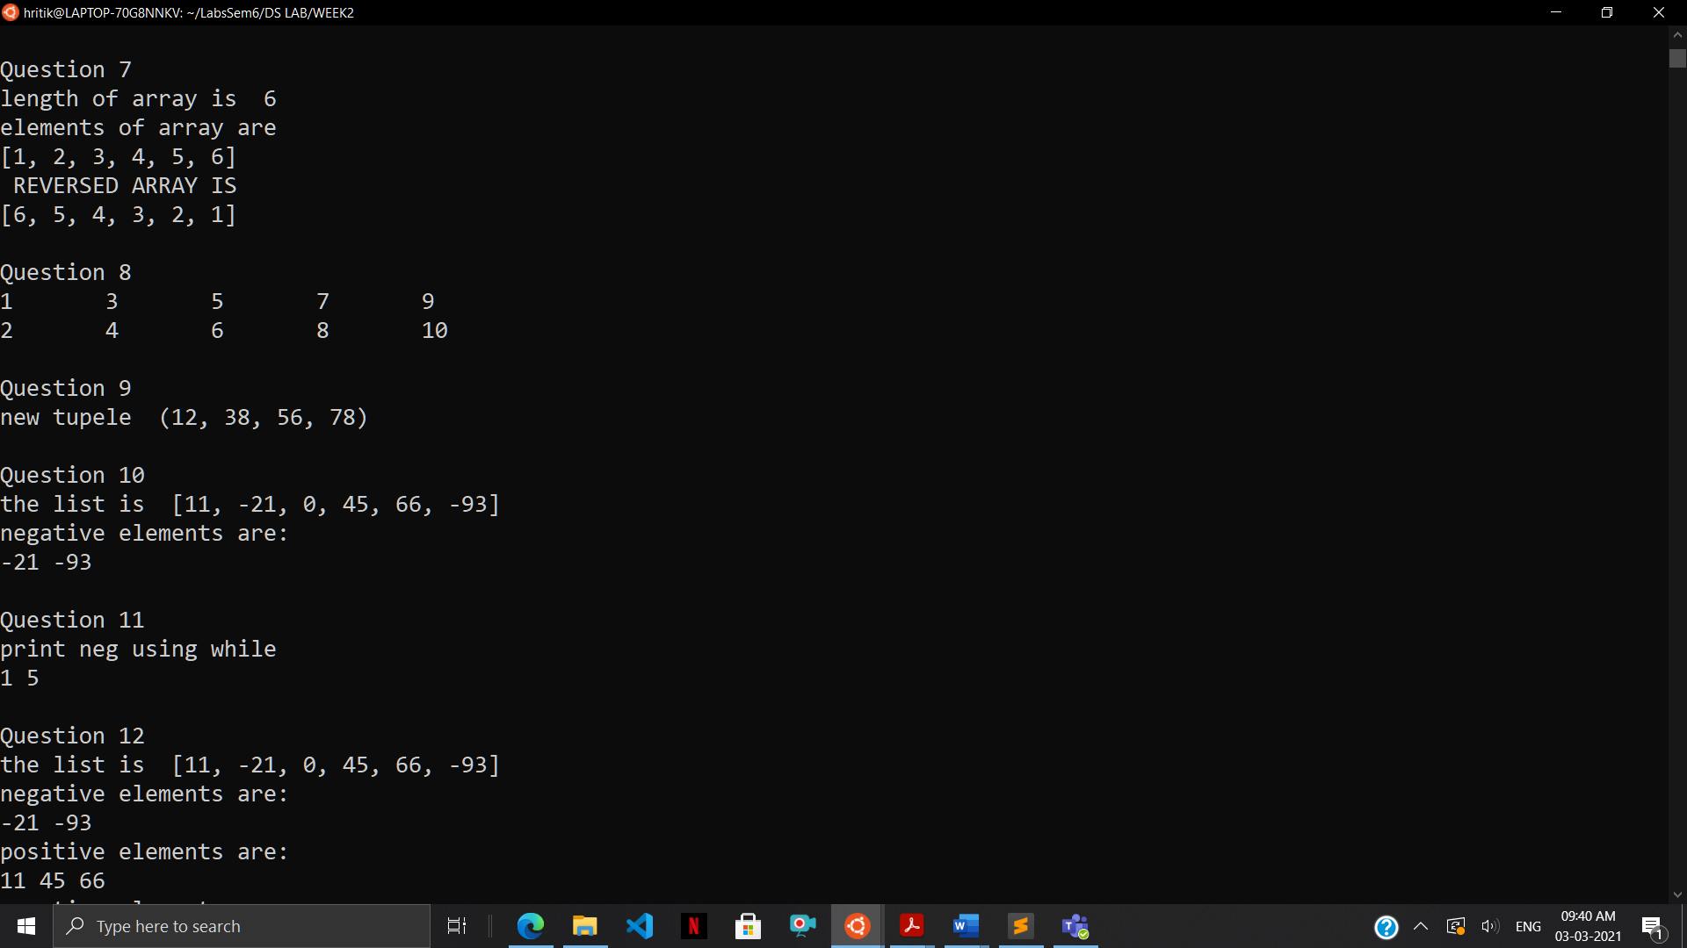

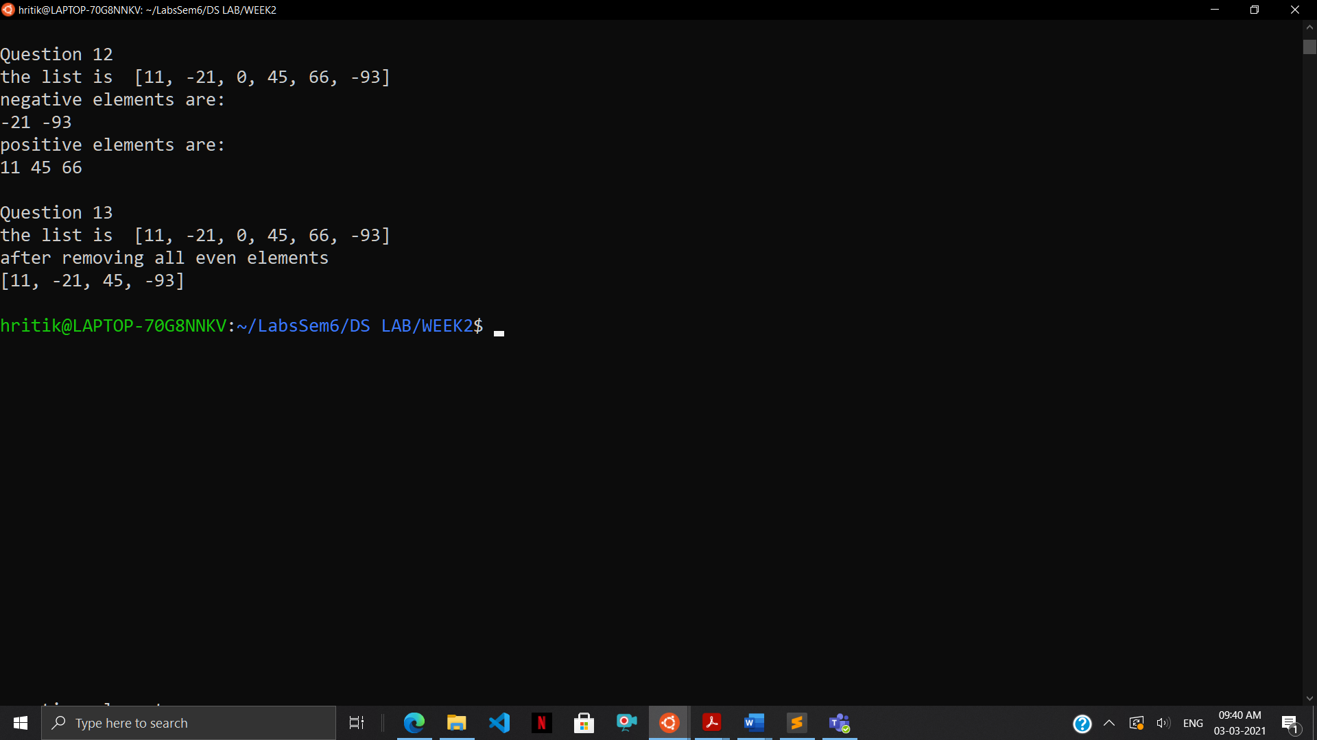

Q14) import pandas as pd

data = {'Name': ['Hritik', 'Harsheet', 'Ravi', 'Akash'] , 'Height': [177, 158, 166, 167],

'Qualification': ['PhD', 'MS', 'MBA', 'BCom.']}

df = pd.DataFrame.from_dict(data)

addr_list = ['Mumbai', 'Delhi', 'Chennai', 'Pune']

df['Address'] = addr_list

print(df.head())

Output:  
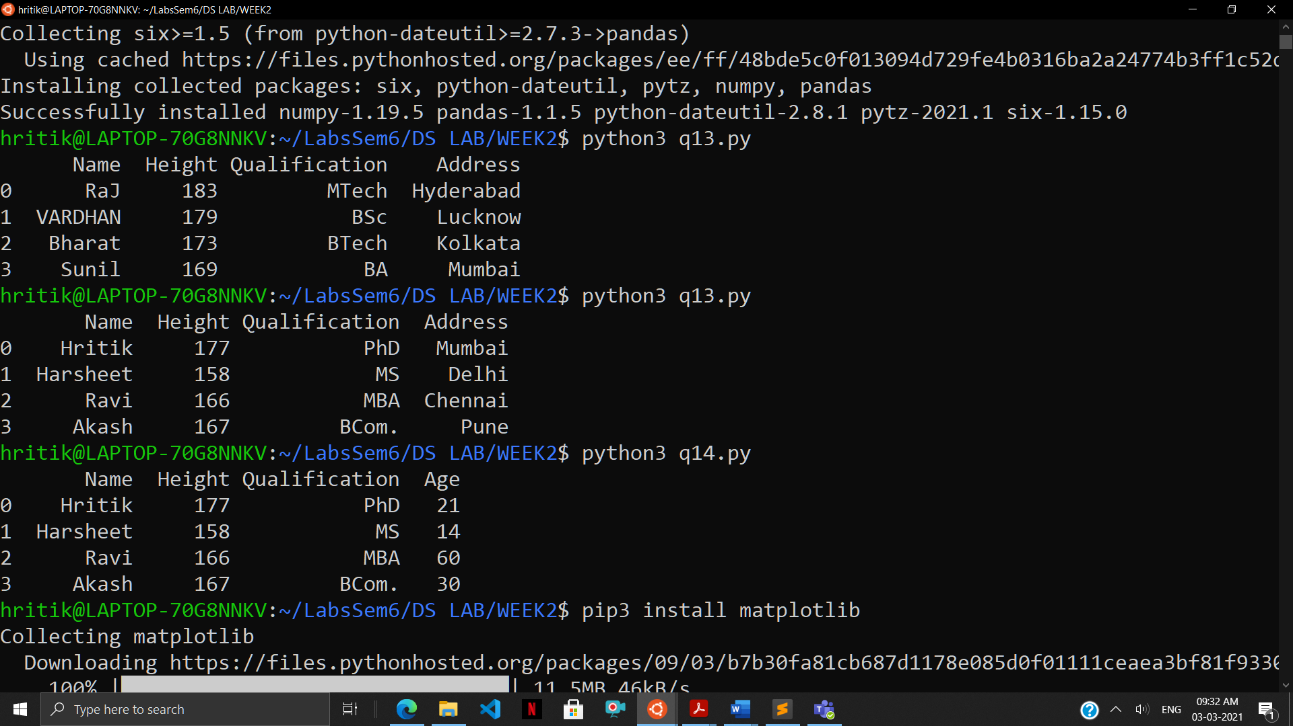

Q15) import pandas as pd

data = {'Name': ['Hritik', 'Harsheet', 'Ravi', 'Akash'] , 'Height': [177, 158, 166, 167],

'Qualification': ['PhD', 'MS', 'MBA', 'BCom.']}

df = pd.DataFrame.from_dict(data)

cols = [21, 14, 60, 30]

df.insert(3, 'Age', cols)

print(df.head())

output:

